# Foams of the future

We use foams every day in our chairs, shoes, or house insulation. Even many natural materials such as wood have a foamy structure. These natural foams are ideal, because they are stiff where needed, light where possible, and allow flow through well-defined paths. However, man-made foams are homogeneous over their entire volume, which means that their performance is usually quite bad as compared to ideal foams as observed in nature.

**This MSc assignment aims to develop our foam printer and print functional 3D foams**. The assignment can include one or more of the following challenges:

* Design and 3D-print optimized nozzles to fabricate the foam
* Test the fluid flow of bubble formation within the nozzle as well as bubble impact on the surface.
* Create foams with useful or unique properties, based on new material mixtures or chemistries. For example:
  + Pressure-sensing with soft sensors
  + Exceptional acoustic insulation or sound focusing
  + Foams with gradients for footwear applications

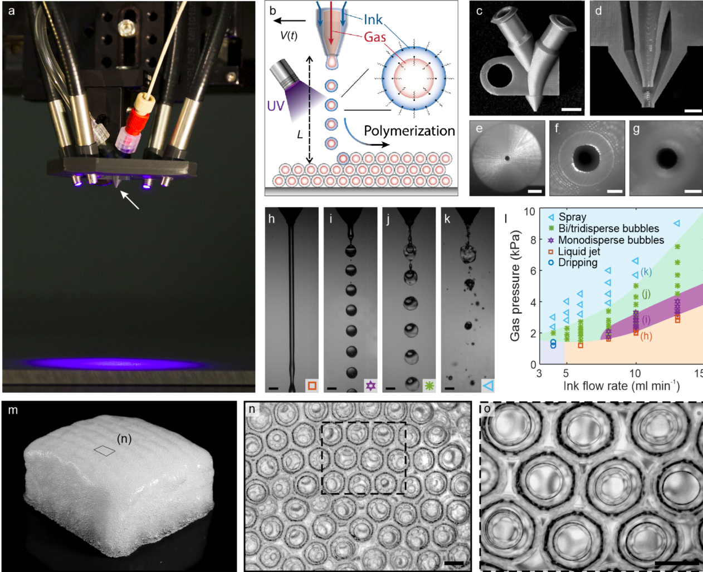

**Figure 1: First results of our foam printing experiments** (1)**. Left: 3D printed foam block of 70x70x35mm3. Center: All the cells in this foam have the same size, which makes the material properties very predictable. Size gradients are also possible, which allows to optimize the properties. In contrast, normal foams have a very broad size distribution! Right: Detail of the center image. Scale bar: 0.5mm.**

***What*** Foam printing! Advance the printer technology and/or print your functional foams.

***How*** With a unique 3D printing process about which we are excited to tell more.

***Why*** Controlled foams are almost impossible to make with current technology, but could improve artificial tissues, shock absorbers, batteries, noise control, etc. Furthermore, you will develop an excellent basis in 3D printing which is a rapidly growing field in research and industry.

***Where*** The Engineering Fluid Dynamics group at the University of Twente, led by Kees Venner. The daily supervision will be by Dr. Claas Willem Visser. You will be part of a collaborative and closely-knit team of MSc students, PHd students, and researchers.

***When*** The starting date is flexible. If you’d like to know more, just email to [c.visser@utwente.nl](mailto:c.visser@utwente.nl).

1. Visser CW, Amato DN, Mueller J, Lewis JA. Architected Polymer Foams via Direct Bubble Writing. Adv Mater [Internet]. 2019 Sep 19;1904668. Available from: https://onlinelibrary.wiley.com/doi/abs/10.1002/adma.201904668